# **Sudhanshu class**

**The Main Difference**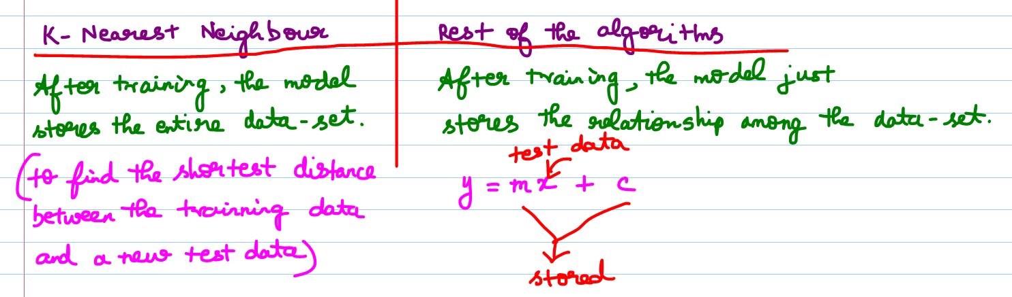

K-Nearest neighbour 🡪 lazy learners.   
It will do nothing until a new test data arrives.   
After arriving with the new data, it simply calculates the distance between the training data-points and the test data.

If the training data is more 🡪 model complexity increases (computationally too costly)

**Basic stuffs**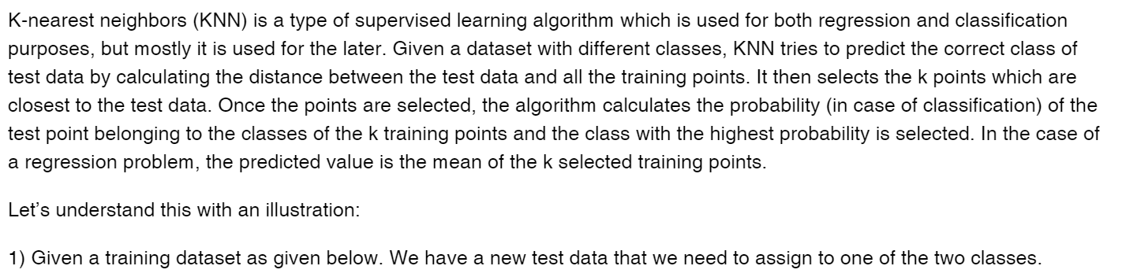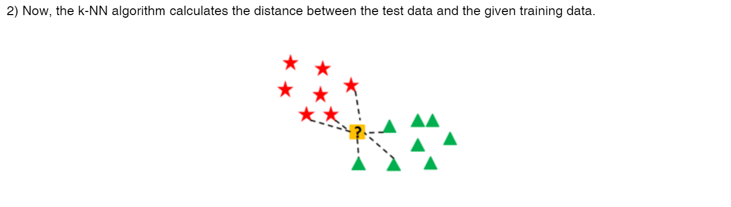

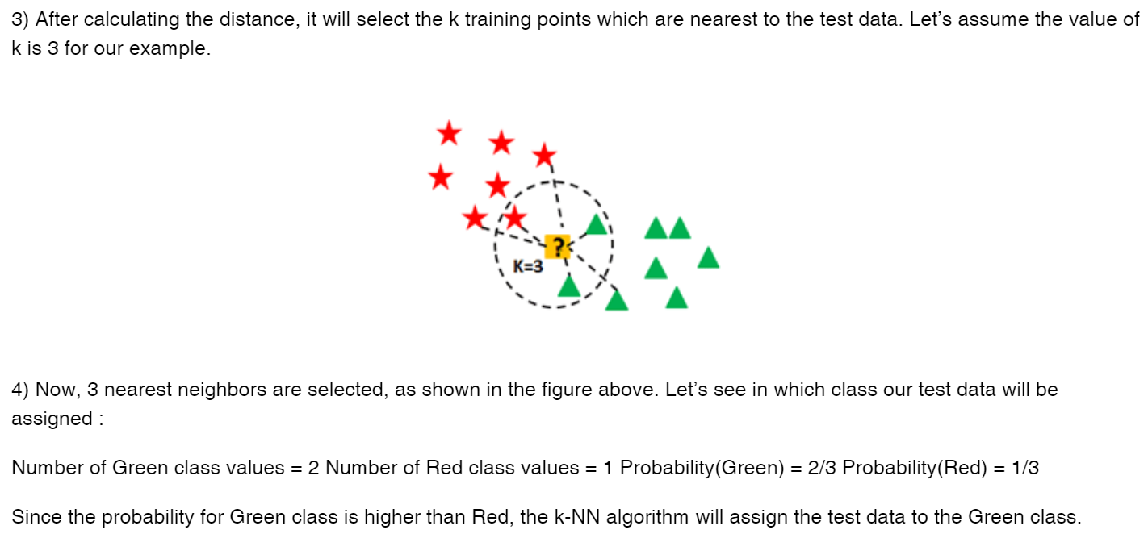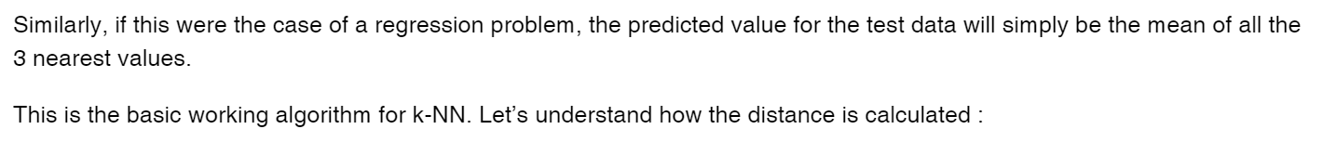

**Distance Calculation**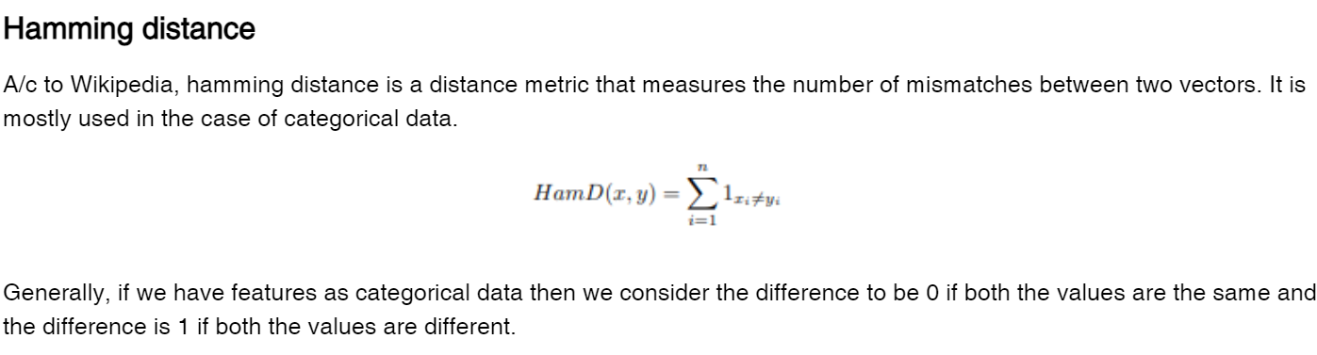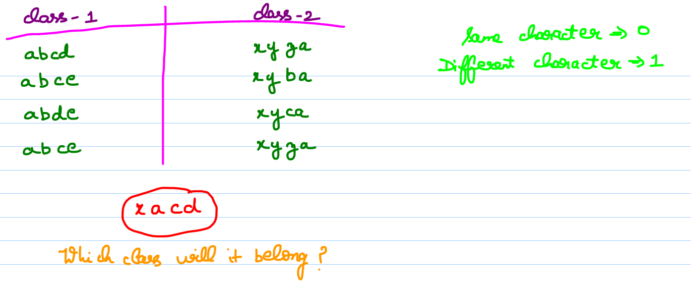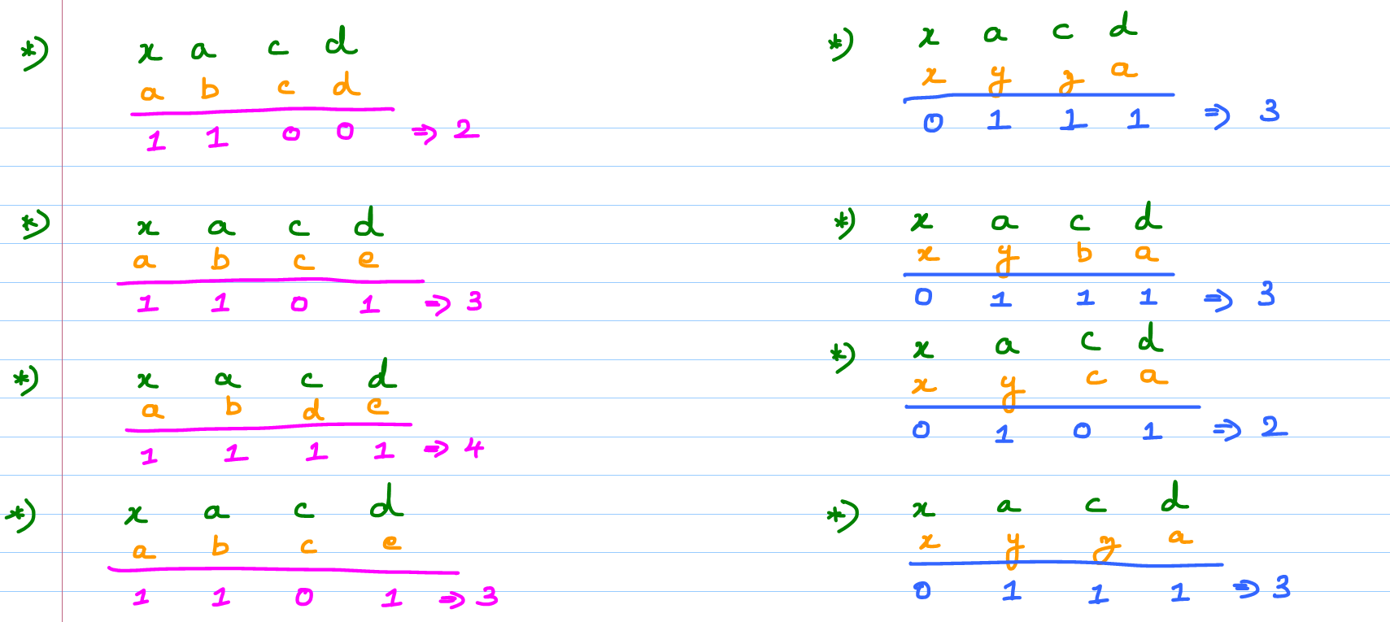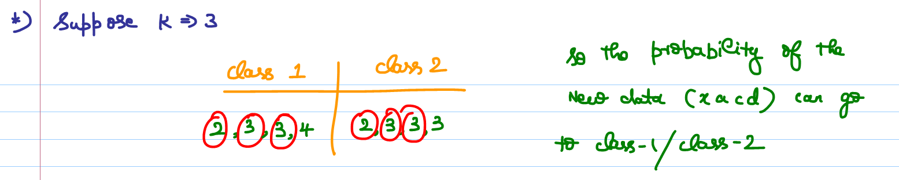

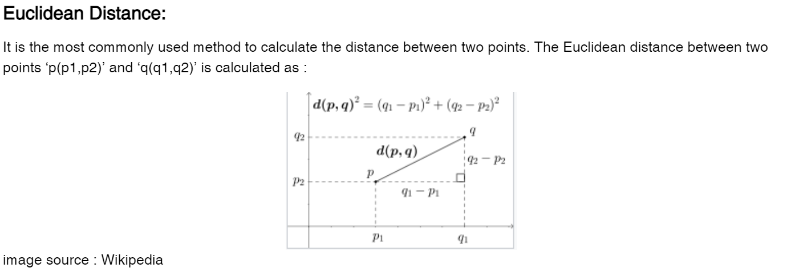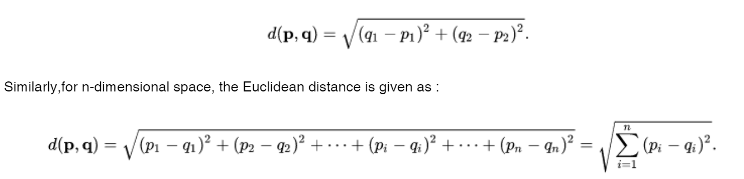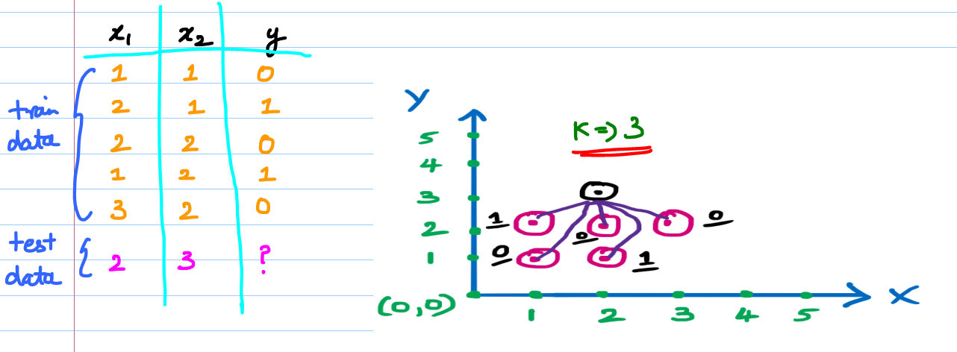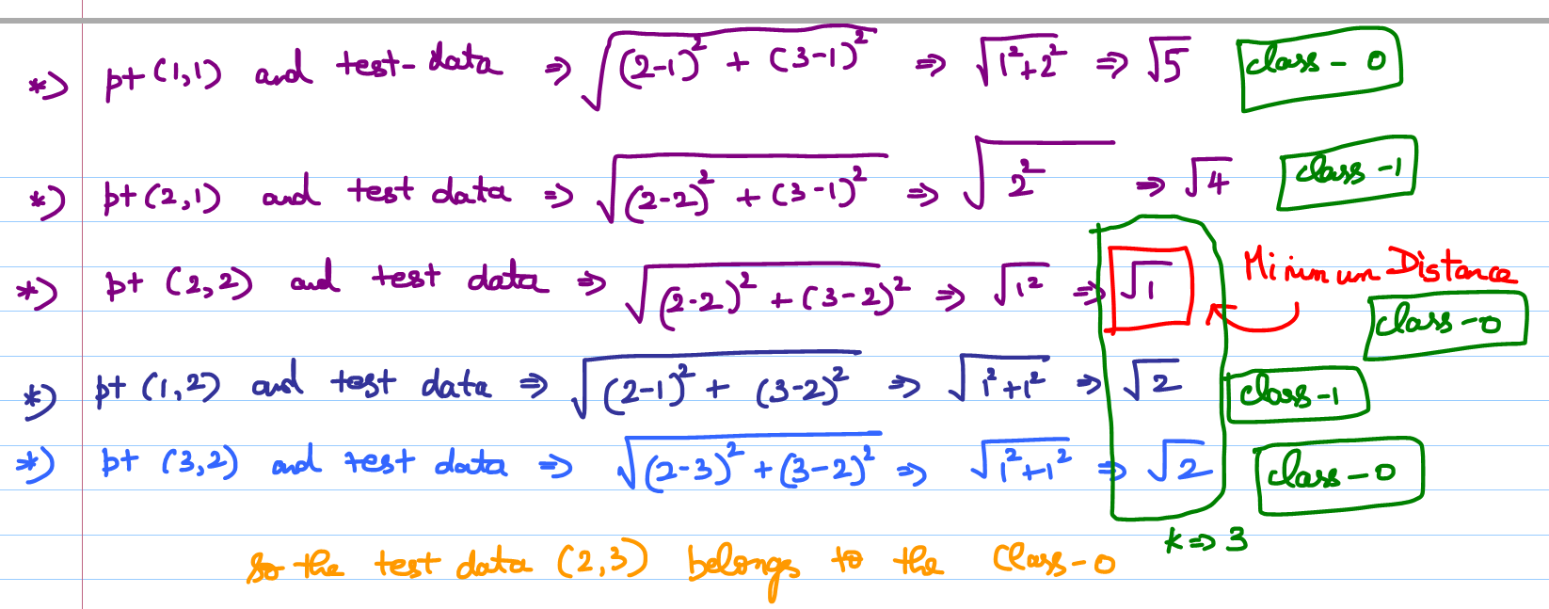

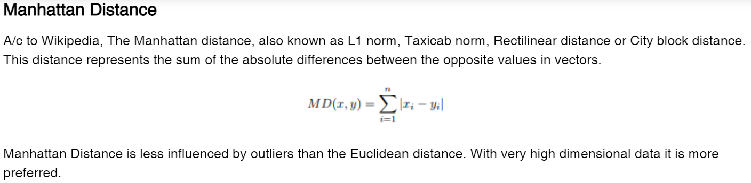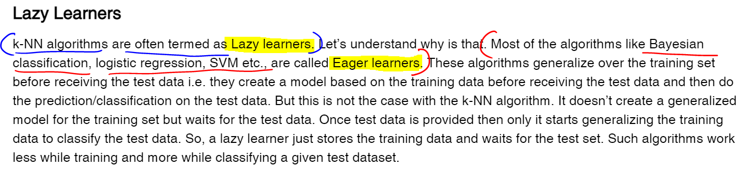If the data-set is huge 🡪 Don’t use K-nearest neighbour.  
If the data-set is small 🡪 Use K-nearest neighbour.

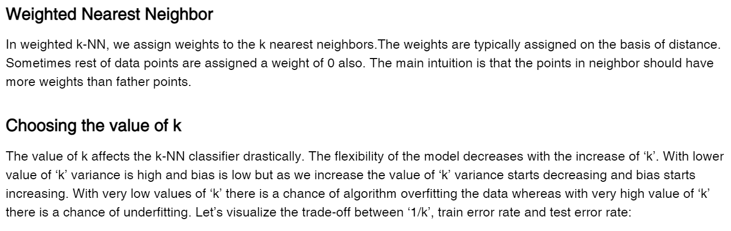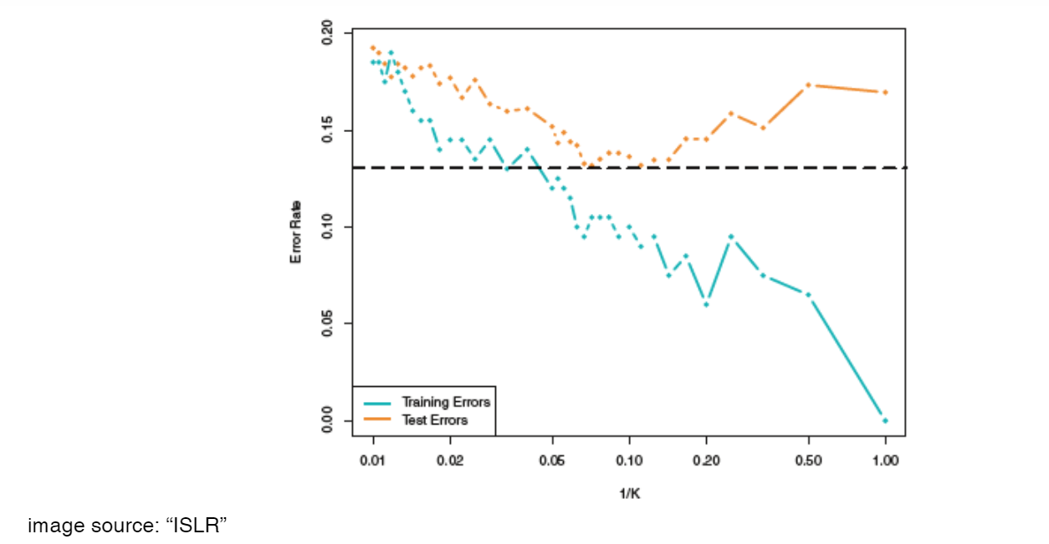

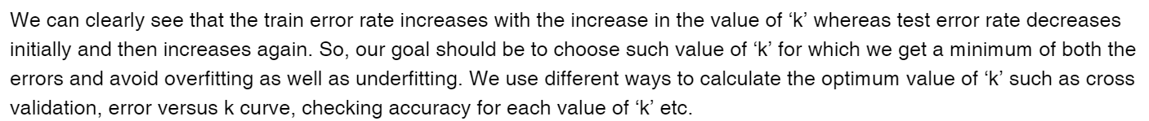

## **Pros and Cons of K-Nearest Neighbour**

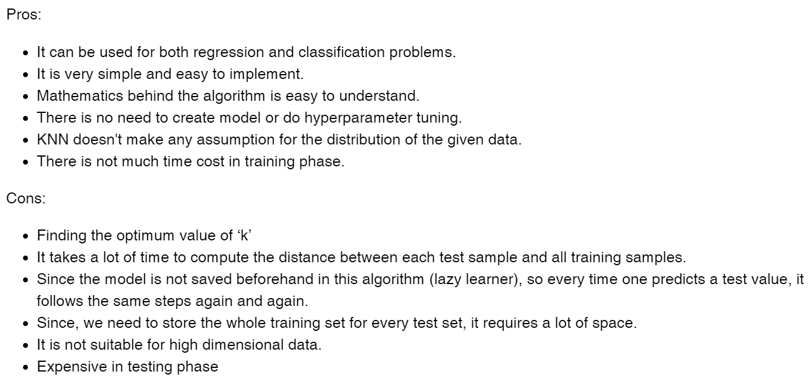

## **Reason for not following K-Nearest Neighbour**

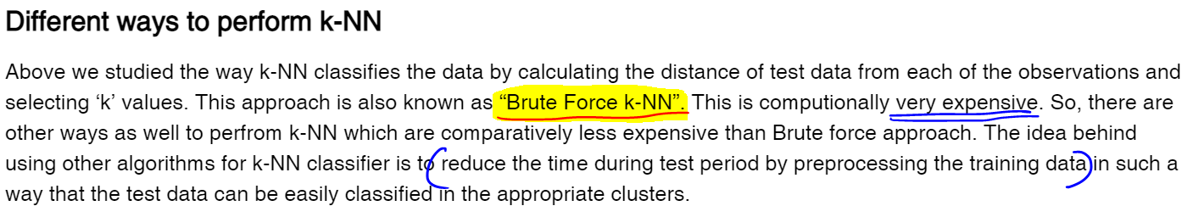

## **K-Dimensional Tree (kd Tree)**

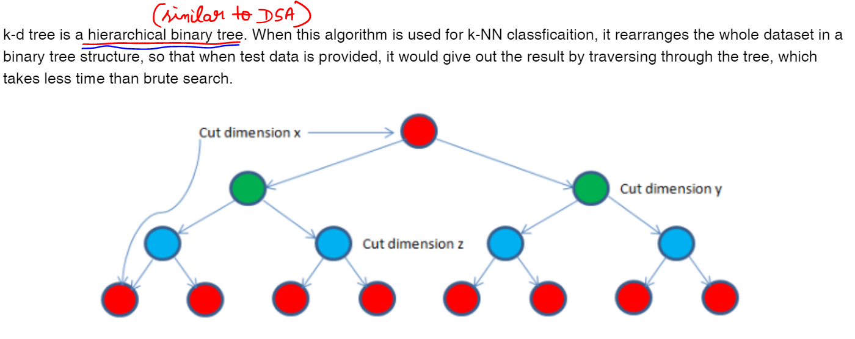

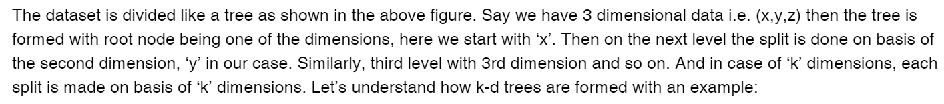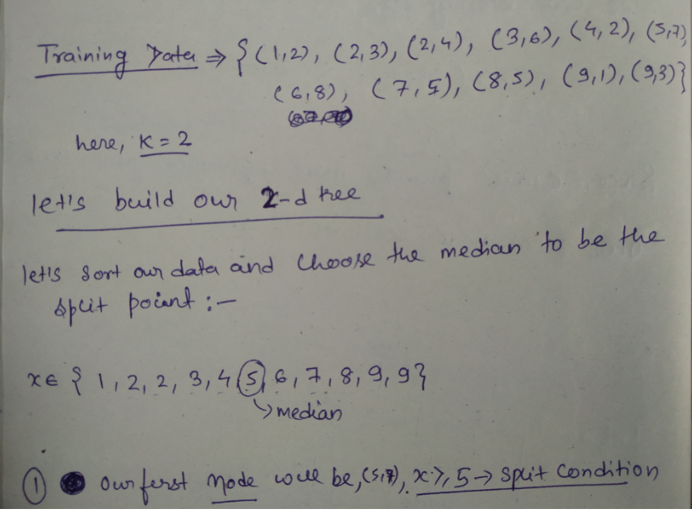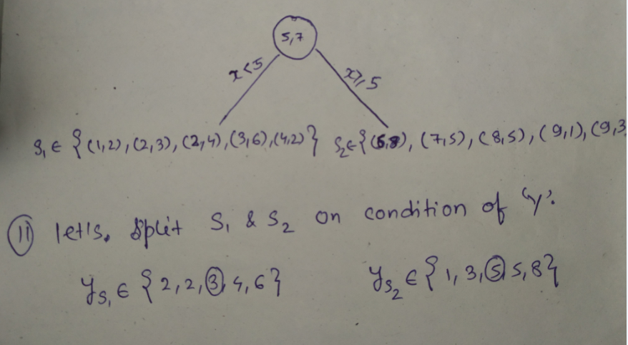

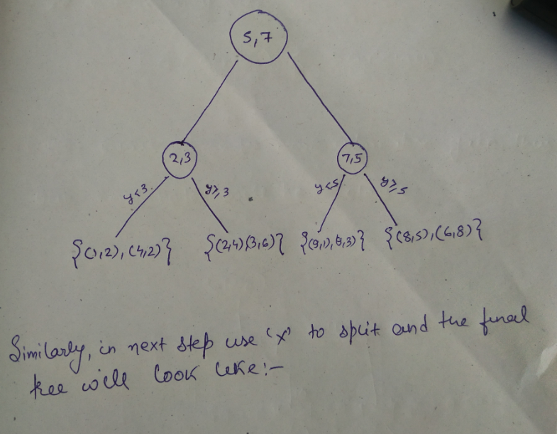  
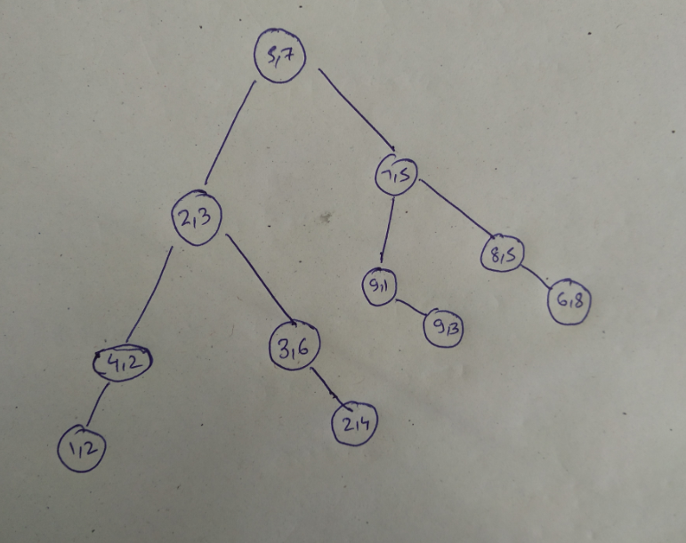

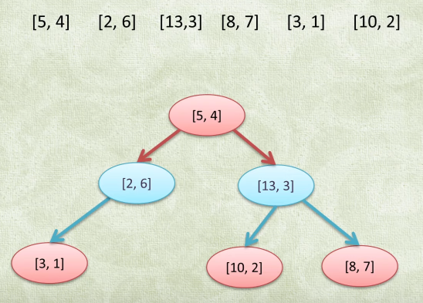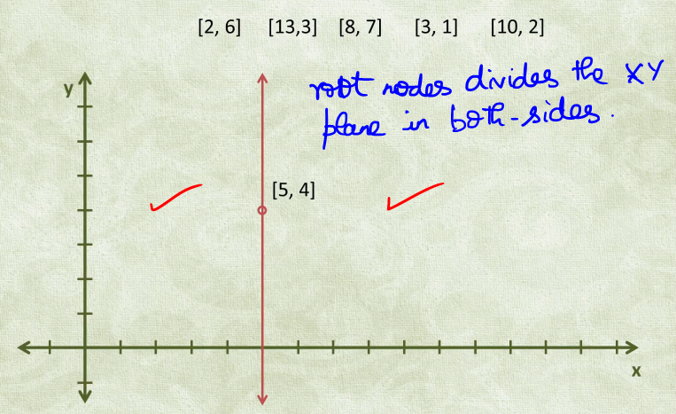

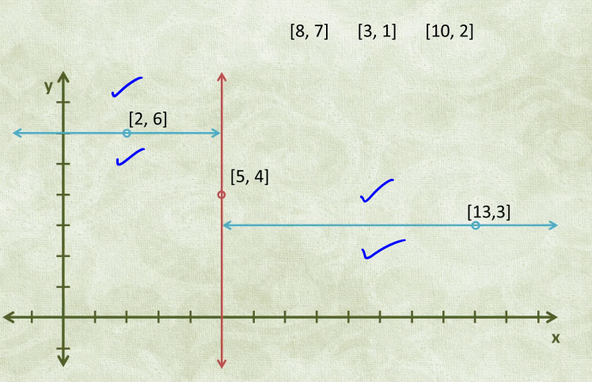

Now the target point is (9,4) and our goal is to find the nearest neighbour.

On-reaching (8,7) we cannot able to fix (8,7) as the nearest neighbour.

The line r is probably going to be at some random diagonal angle. But if the line directly perpendicular to the section that we chose not to visit when recursing down is shorter, then there is a chance that the section[yellow region] may have a closer point.

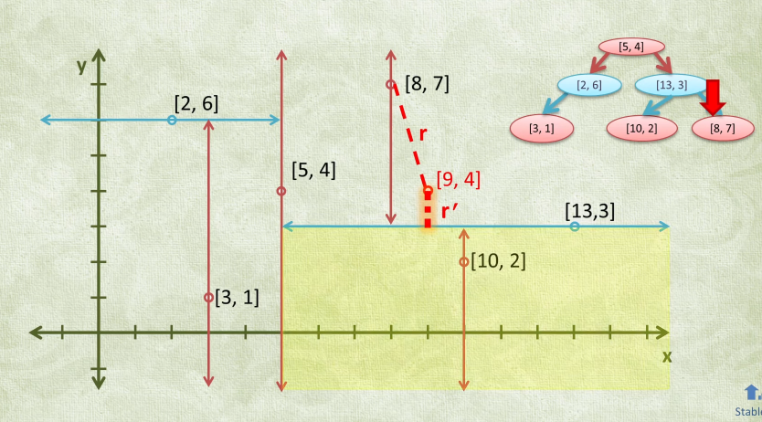

This is where the magic happens.  
As we recurse back, we also calculate the distance to the section that we did not visit. If that distance, lets call it r-prime is smaller than the best distance (8,7) found so far, then we traverse into the section as well.

Note that this does not mean that we visit every node in the tree.  
If the height of the tree is H, then at-most we will visit 2H nodes. [logarithmic search]

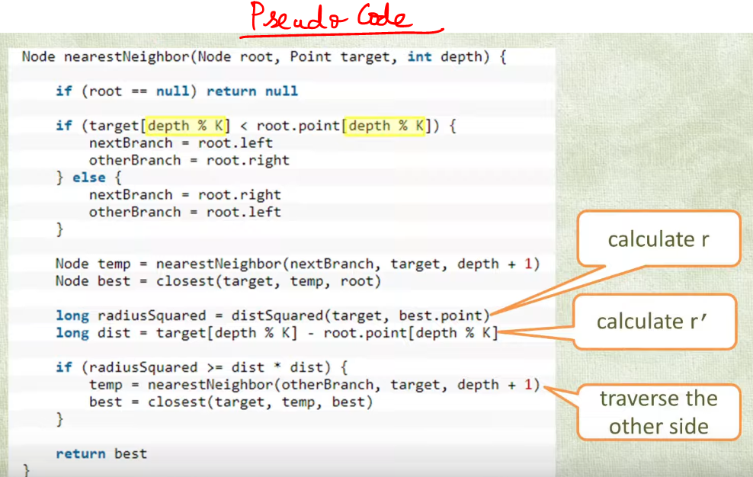

## **Ball Tree**

# **Krrish class**

**Classification perspective**

Red points 🡪 class A  
Orange points 🡪 class B  
Want to find where the green point belongs to????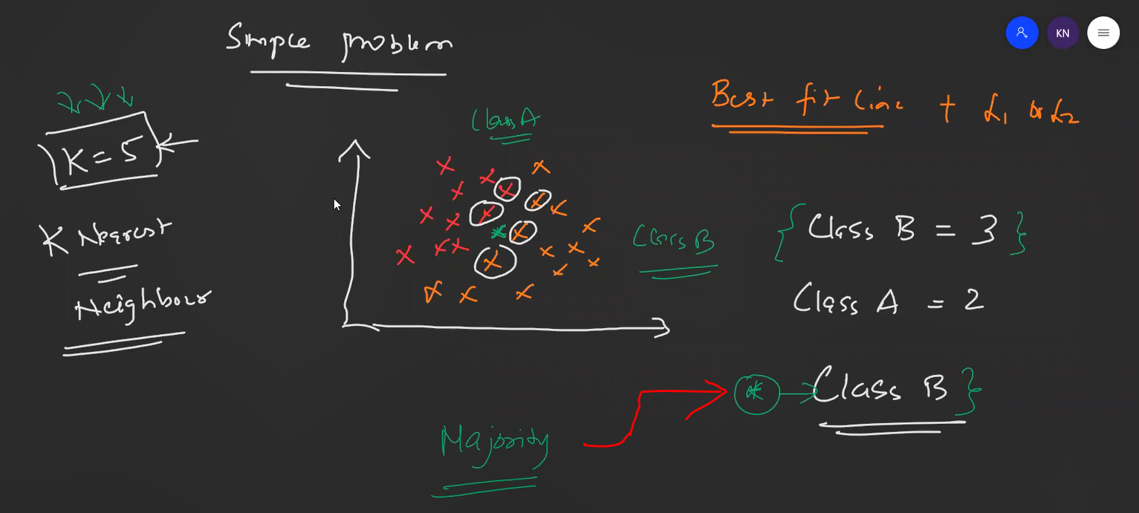

That green point belongs to Class-B since it was the majority.

**Regression perspective**

**What will be the hyper parameter ??**K Nearest Neighbour 🡪 K (See practical implementation)

**What will be K value 🡪 Odd/Even ??**Definitely odd value, since  
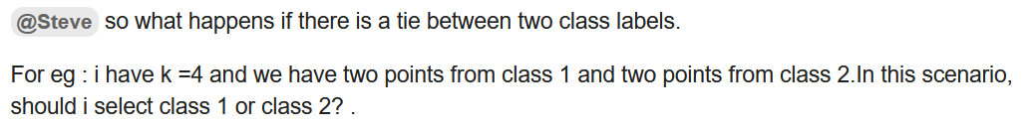

**Why KNN is not used for outliers/imbalanced data-sets ??**

Class A 🡪 white points  
Class B 🡪 orange points  
Where the new red point belongs to ?? 🡪 Its not possible to say.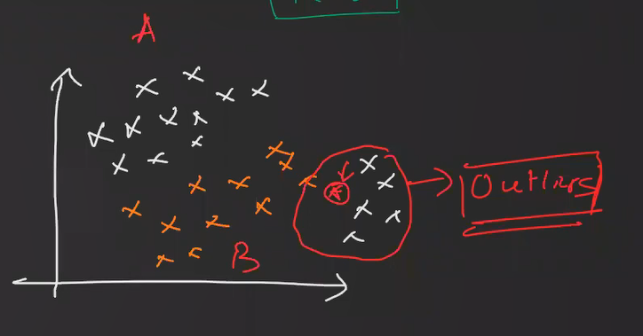

With Box plot and IQR, outliers will be removed.

**Calculating Distance**

Euclidian distance from Pythagoras theorem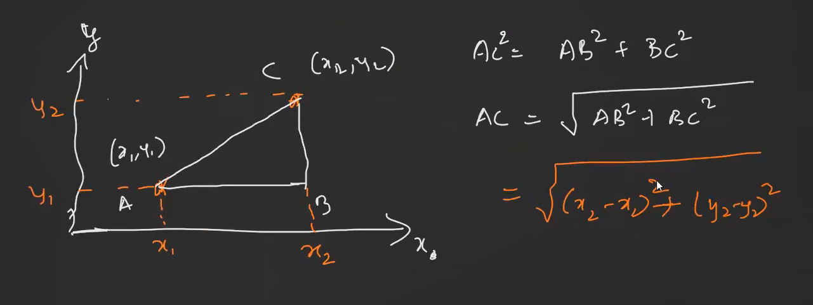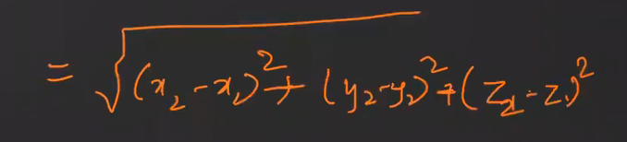 **3D perspective**

Manhattan Distance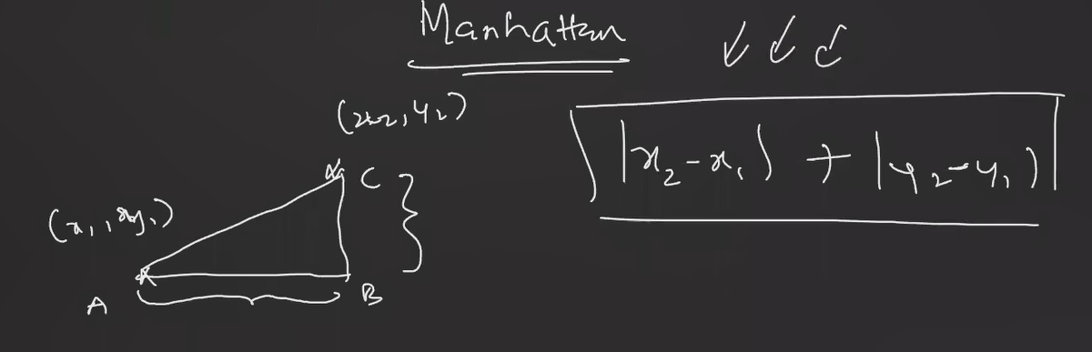

Which ever-algorithms standardization required ????  
Algorithms involving distance,

Interview Question

**KNN Scikit Learn**

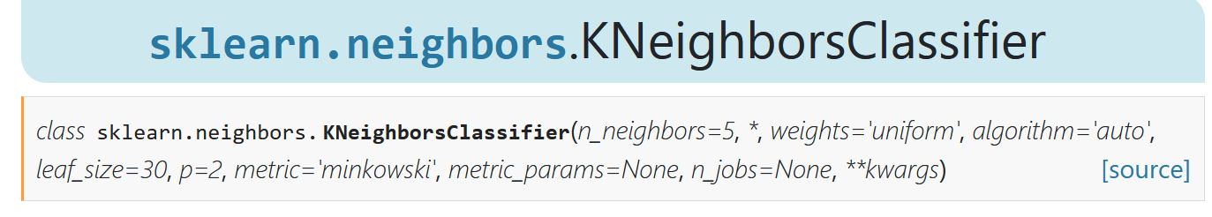

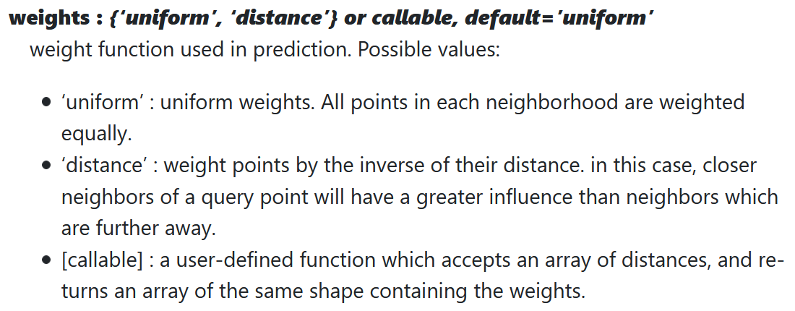

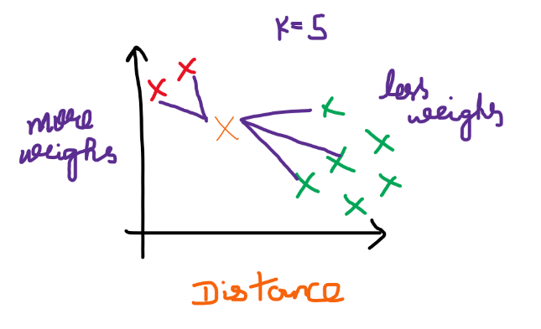  
Distance --> for imbalanced data-set

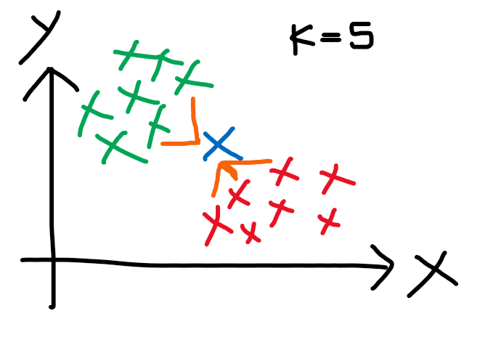  
Uniform 🡪 Used for Balanced Data-Set

far-away points --> less weighs  
near points --> more weighs  
Take the nearest points and see the majority and assign that query point to that majority class.

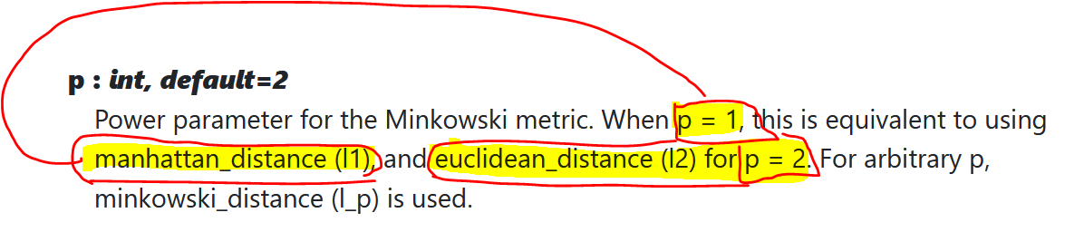

References

https://www.youtube.com/watch?v=Glp7THUpGow